CA 3: Experiential Learning

Group Members:

|  |  |  |  |
| --- | --- | --- | --- |
| Sr. No. | PRN | Name of Student | Mail id |
| 1 | 22070122031 | Arnav Khandelwal | arnav.khandelwal.btech2022@sitpune.edu.in |
| 2 | 22070122036 | Aashmit Mckenzie | aashmit.mckenzie.btech2022@sitpune.edu.in |
| 3 | 22070122038 | Atharva Gondhali | atharva.gondhali.btech2022@sitpune.edu.in |

Problem Statement:

To create a C++ program for an Animal Information System that allows users to choose a particular animal from a given list and learn the basics of it like their diet and the region they are usually found in.

Explanation:

This is a menu-driven code that allows the user to select any animal and get its details, this program contains the following details:

1. Name
2. Place in the Animal Kingdom
3. Type of Blood
4. Diet
5. Places usually found in

This code was written with the help of multilevel inheritance and polymorphism

Polymorphism is used in 2 ways:

1. Function overriding in a virtual function “virtual void sound_made()”.
2. Dynamic Binding is used while creating an array of pointers in base class animal to store the data of each animal.

Inheritance is used as shown in the diagram below.

Class Diagram:

Code snippets:

Input/Output:

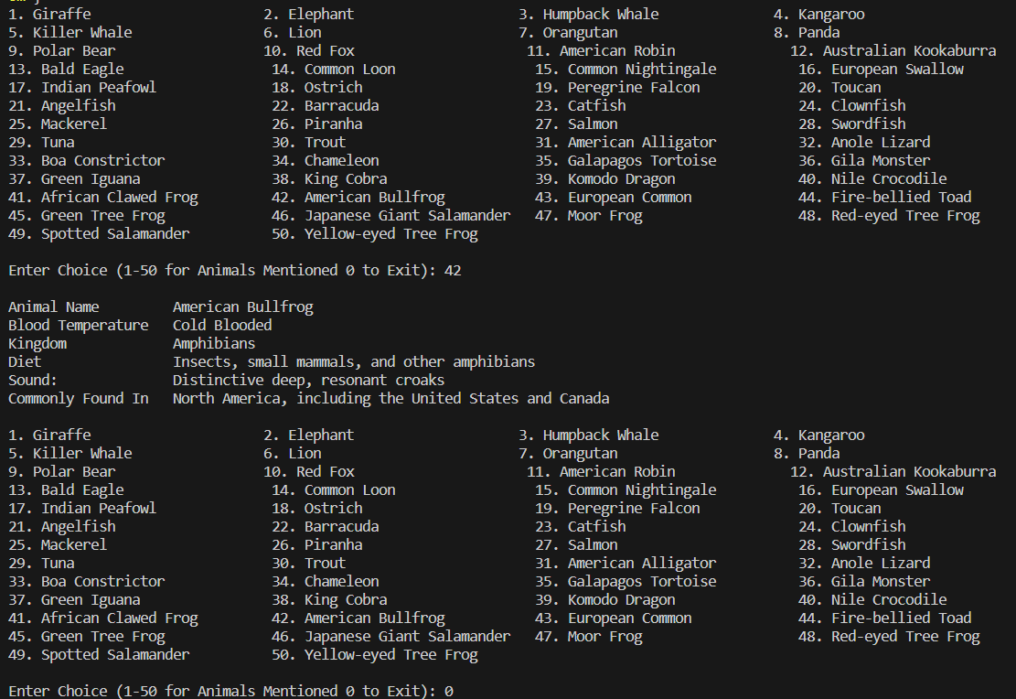

Github repository link: